Climatic extremes erode the temporal architecture of seasonal communities

Volker H. W. Rudolf^{1*}, Daniel Saenz²
Affiliations:
¹Corresponding author, Program of Ecology & Evolutionary Biology, BioSciences, Rice University; Houston, TX 77005, USA
²USDA Forest Service Southern Research Station; Nacogdoches, TX 75965, USA
*Corresponding author: Volker.rudolf@rice.edu

Abstract
The temporal organization of communities is the foundational blueprint for ecosystem functioning, yet the mechanisms shaping this architecture remain elusive. Using a temporal network framework to decadal, multi-site data on amphibian breeding, we resolve this by revealing a dynamic “small-world” architecture of seasonal community transitions. This structure is shaped by consistent scaling rules and the interplay between local environmental filters and interannual climate variability. However, drought and heat conditions simplify this temporal organization, as extreme climatic forcing overrides seasonal coordination among species and reduces modularity, community state and transition diversity, creating a simpler, more centralized architecture. This loss of complexity suggests that increasing weather extremes do not merely stress species but dismantle the structural organization of natural ecosystems, potentially eroding their resilience to future perturbations.
Main Text:
Ecological communities are not static entities, but instead transient assemblages that fluctuate as species emerge, become active, migrate, reproduce, or go dormant at different times (1-5). While the spatial redistribution of biodiversity under climate change has been extensively studied, we still lack a comparable understanding of the temporal organization of seasonal communities and how it responds to climate change (6, 7). This organization represents the temporal patterns in community composition defined by the precise sequence and timing of species co-occurrences (6). Because community members typically respond idiosyncratically to environmental cues (8-12), climate change has the potential to reshape the temporal organization of seasonal communities. Since this architecture defines species interactions, energy flow, disease transmission, and ecosystem resilience (6, 13-17), filling this conceptual gap is critical to understanding the fundamental mechanisms that shape natural ecosystems and their resilience in the face of a rapidly changing climate.
Research on intra-annual (seasonal) community patterns has largely relied on “snapshot” approaches that compare community diversity metrics or networks at discrete time points (1, 4, 18-22). While this pioneering work revealed how rapidly communities can turn over, these methods inherently overlook critical components of the underlying temporal organization. Specifically, they miss the full specific sequence of community states, the exact timing of transitions, and the durations between them (6, 7). Furthermore, while the effects of interannual weather fluctuations and climate change on phenologies are well documented (13, 23), we still lack a general understanding of how these shifts scale up to alter the internal temporal structure of entire communities. Resolving how climate shapes this temporal blueprint of communities is historically challenging because it requires high-resolution, long-term datasets across multiple communities to identify general patterns, and analytical tools capable of mapping rapid intra-annual shifts in community composition. Here, we tackle this challenge by applying a novel transition network framework to a 24-year dataset of 841,632 observations of daily breeding activity of 12 amphibian species across 8 sites in eastern Texas, USA. By treating community states as nodes and transitions as edges, we characterize the temporal architecture of 192 unique annual communities to identify general rules governing their temporal architecture and their conservation across time and space (Fig. 1). This framework allows us to move beyond static snapshots toward a mechanistic understanding of how climate variability and extreme events reshape community dynamics at ecologically relevant timescales, in one of the most threatened taxonomic groups globally (24). 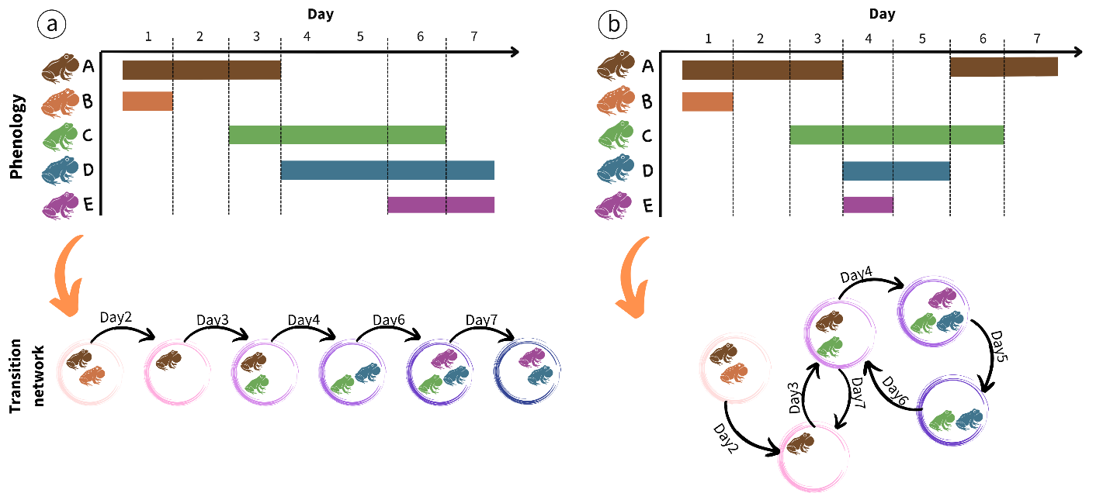
Fig 1: Quantifying intra-annual changes in community structure with transition networks. Transition networks are created from breeding phenology data for community members (colored horizontal bars). Nodes represent community states, defined by a unique combination of co-occurring species and links indicate transitions between states when species enter or leave the community (dashed vertical lines). Each node and edge has time stamps, creating a time-ordered network that fully captures the exact sequence and duration of and between changes in community structure on a fine temporal scale. We then test how the network architecture changes across years and sites, and climatic conditions by comparing key network metrics (Table 1). The left side shows a hypothetical example of a simple linear, sequential transition typically expected in classical seasonal succession; the right shows a more complex temporal structure with recurring states and repeated transitions found in this study.
Table 1: Metrics to quantify different aspects of the temporal structure of communities.
Scope | Metric | Description
Network | Node diversity | Metric of network size indicating the total number of unique community states
 | Connectance (weighted) | Metric of network density indicating average transitions (in & out) per community state
 | Modularity | Metric of network structure; higher values indicate more grouping/clustering of community states
 | Betweenness centralization | Metric of network centrality; high values indicate network “bottlenecks” or key node hubs
 | Mean Distance (Average Path length) | Metric of network efficiency; lower values indicate signals can spread faster (small word structure)
Node | Frequency | Average frequency a community state appears
 | Duration | Average duration of states
 | Skewness of duration | Asymmetry in state duration
Edge | Weight | Average frequency of transitions between states
 | Skewness of weight | Asymmetry in frequency across different transitions
Temporal spacing | Burstiness | Temporal distribution of community transitions
 | Memory | Correlation of durations between transition events
 | Event rate | Rate at which transitions accumulate over time

The temporal architecture of communities
Quantifying key metrics (Table 1) that describe the architecture of the 192 transition networks revealed a highly dynamic seasonal community structure. In a single annual activity cycle, communities went through an average of 20.3 (±0.73 SE) unique community states (combinations of co-occurring species) and 88 (±1.99 SE) transitions between states, with up to 51 unique community states and 158 transitions (Fig. 2). This striking diversity of community states and high frequency of transitions within a single cycle was possible because each state lasted, on average, only 3.1 days (±0.05 SE). Notably, state durations followed a negative exponential probability density function $(P\left(d\right)\sim e^{-λd})$ (Fig. S3), suggesting that the end of a state is independent of its duration and thus driven by external forcing rather than internal aging of nodes. This aligns with the fact that transitions between community states depend on the activities of all community members rather than the phenology of just a single species.
The transitions between states were moderately bursty (mean = 0.21 ±0.01SE, Fig. 2). We did not detect a signal of temporal memory (mean = -0.04 ±0.001, Fig. 2), indicating low predictability of the timing and duration of events. Together, these results reveal volatile seasonal structure, with temporally clustered transitions between ephemeral community states, separated by longer “stable” periods with few changes in community composition. This temporal structure of events is consistent with the system's biology: Although breeding activity varies across amphibian species, it is still typically coordinated around the same stochastic weather (e.g. rain) events for most species (25), which helps explain the observed level of temporal clustering and stochasticity at the community level.
The sequence of community state transitions created complex, interconnected networks, with some clear general characteristics. Networks were typically modular (mean = 0.32 ± 0.01 SE, Fig. 2), revealing that states grouped into more interconnected seasonal clusters. This is consistent with the concept of “seasonal guilds” (26, 27), in which subsets of species overlap in their seasonal niches but differ in their fine-scale activity patterns. While connectance was, on average, low relative to the high node diversity (mean: 0.15 ± 0.006 SE, Fig. 2), it was still surprisingly similar to the average connectance reported for most ecological networks (28). Given that our analysis focused on a fundamentally different network type (temporal transitions of community states vs. static interactions among species), this underscores the need to expand current empirical and theoretical research on the mechanisms that structure self-organizing systems to include time-explicit networks.
Contrary to the topology expected from classic linear seasonal succession (Fig. 1), we found that these community transition networks exhibit a “small-world” configuration. This structure is defined by a short average path length (2.18 ±0.07SE, Fig. 2), indicating that most community states are separated by less than two transitions, and a high betweenness centrality (0.49 ±0.001SE, Fig. 2), which identifies how often nodes act as mandatory bridges or “hubs” within the network. A closer inspection of individual networks revealed that these central transition hubs were either “empty” states (no active species present) or states dominated by a single species with an extended breeding phenology, like the bronze frog (L. clamitans). Such critical functional roles only emerge through a temporally explicit lens. Ultimately, this interconnected structure suggests that seasonal amphibian communities do not progress through a rigid, chronological sequence, but instead maintain a highly plastic transition network centered around a few key mediating states.
Stability and variation in seasonal structure
Determining whether climate-driven changes in the temporal organization of communities follow universal rules that are preserved across communities is crucial for predicting the effects of climate change across heterogeneous landscapes. We found that the seasonal architecture of communities exhibited significant spatiotemporal divergence across sites and years (Fig. 2, Table S1, S2). For instance, the diversity of unique nodes (representing distinct community states) varied tenfold (5-51) across the 192 networks, and up to fivefold within individual ponds across years (Fig. 2). This variation was largely driven by changes in the cumulative annual species richness, which scaled log-linearly with node diversity (Fig. 3). Crucially, this scaling relationship was conserved across all sites, revealing a predictable, non-random assembly rule that links species richness to the diversity of realized community states. While exponential scaling between richness and connectance is well documented for traditional ecological networks (15), our results demonstrate that this relationship extends to time-ordered networks, potentially representing a universal rule for ecological communities across time and space.
Furthermore, as the number of active species increased, the disparity between the observed and theoretically possible node diversity widened significantly (Fig. 3). This divergence underscores that the number of realized species combinations is strongly constrained by temporal overlap and should therefore be common in any system with temporal niche partitioning. Since co-occurrence strongly determines species interactions (3, 29), our results indicate that the temporal structure of communities plays a critical, yet traditionally overlooked, role in shaping interaction networks.
After controlling for annual species richness, most temporal structure metrics still differed significantly across sites and years (Table S.2). The notable exceptions are betweenness, burstiness, and the significant positive correlation between the average duration of community states and their frequency of occurrence each year (r² mean = 0.561, range = 0.522-0.601, Fig. S2), which all remained relatively consistent across ponds. Despite their spatial consistency, these metrics still fluctuated substantially over time (Fig. 2, Table S.2). Consequently, while certain properties of community transitions appear conserved, the broader temporal architecture of communities is plastic, shaped by spatiotemporal variation in local environmental conditions and community composition.
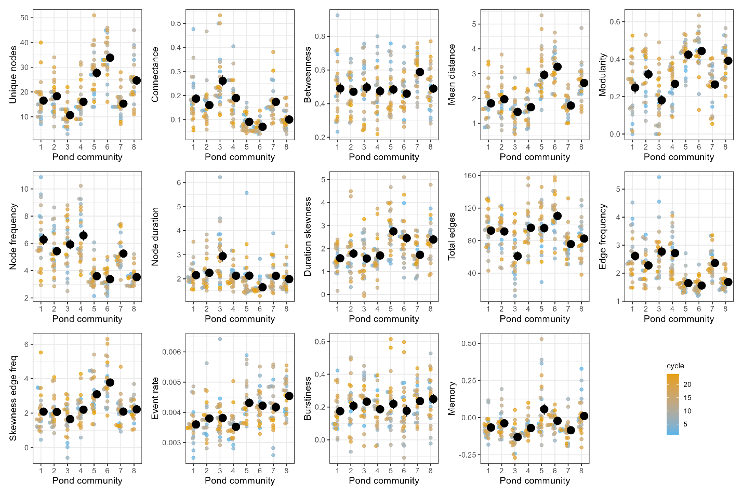
Figure 2: Temporal (seasonal) structure of community transitions varies across sites (ponds) and years. Solid black points indicate pond means ±1SE across years, and small points indicate the respective metric for a given year, with the color indicating the respective annual cycle. See Table 1 for details on network metrics.

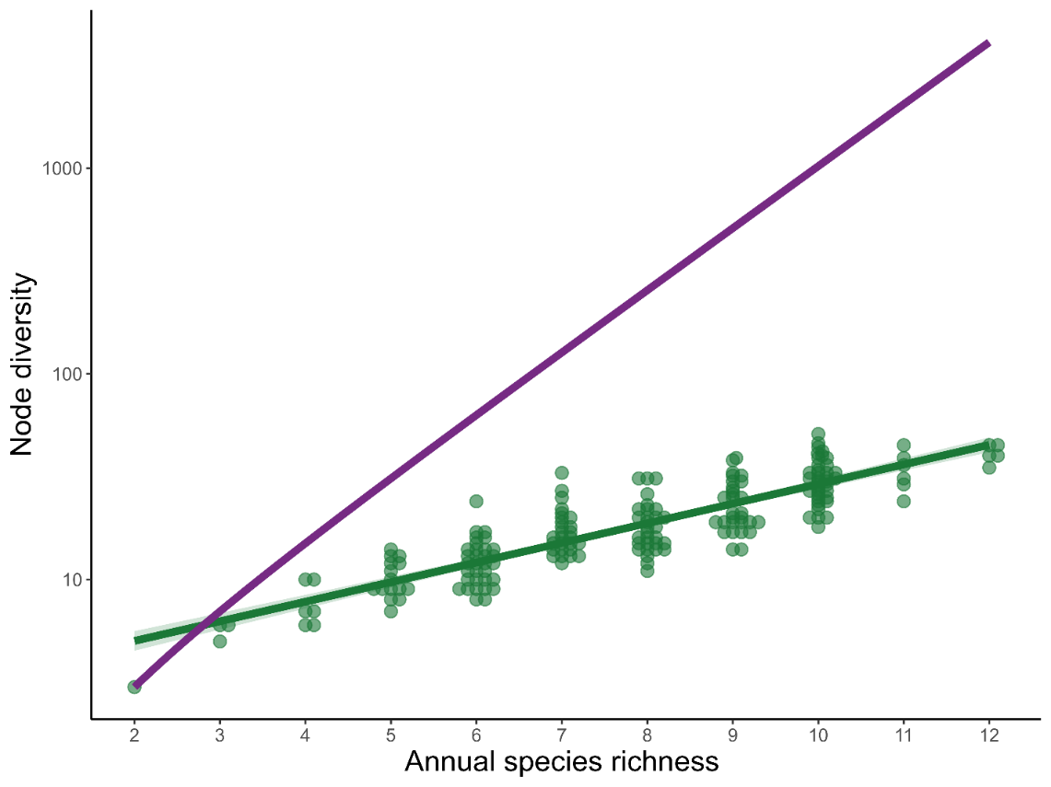
Figure 3: The diversity of community states in a transition network scales positively with the number of active species each year. The purple line indicates the hypothetical maximum number of unique states, assuming no phenological differences. Points indicate data of a given pond and year combination, jittered horizontally for clarity, and the green line and shaded area indicate the corresponding best-fit model and CI, respectively. Note log-scale of the y-axis.

Climate drives inter-annual variation in seasonal community structure
Climatic variability over the 24-year period accounted for a significant part of the inter-annual changes in the temporal architecture of communities. Specifically, 12 of the 14 transition network metrics were significantly associated with at least one principal component of weather variation (Table S3). This spanned all metrics of network topology, as well as the most node-level, edge-level, and temporal spacing properties (Fig. 4A). Given the respective axes loadings, this suggests that drier and hotter conditions (associated with high values on PCA1, Fig. S1) result in smaller (fewer unique nodes), less modular networks that are more connected but have fewer total edges (transitions). In other words, these conditions reduce the volatility, diversity, and complexity of seasonal community changes. In contrast, colder nights and irregular and temporally clustered rain pulses (associated with negative values on PCA2, Fig. S1) increased modularity and burstiness but decreased connectance, betweenness, and node duration. Thus, as rain events become more pulsed and spread out, species activities (and thus community states) become shorter and temporally separated, creating a more compartmentalized and fractured community transition network. While the effect of climate change on species phenologies is well-documented at the species level (9, 12), our results reveal the pervasive impact of climate forcing on the fine-scale temporal architecture of entire communities.

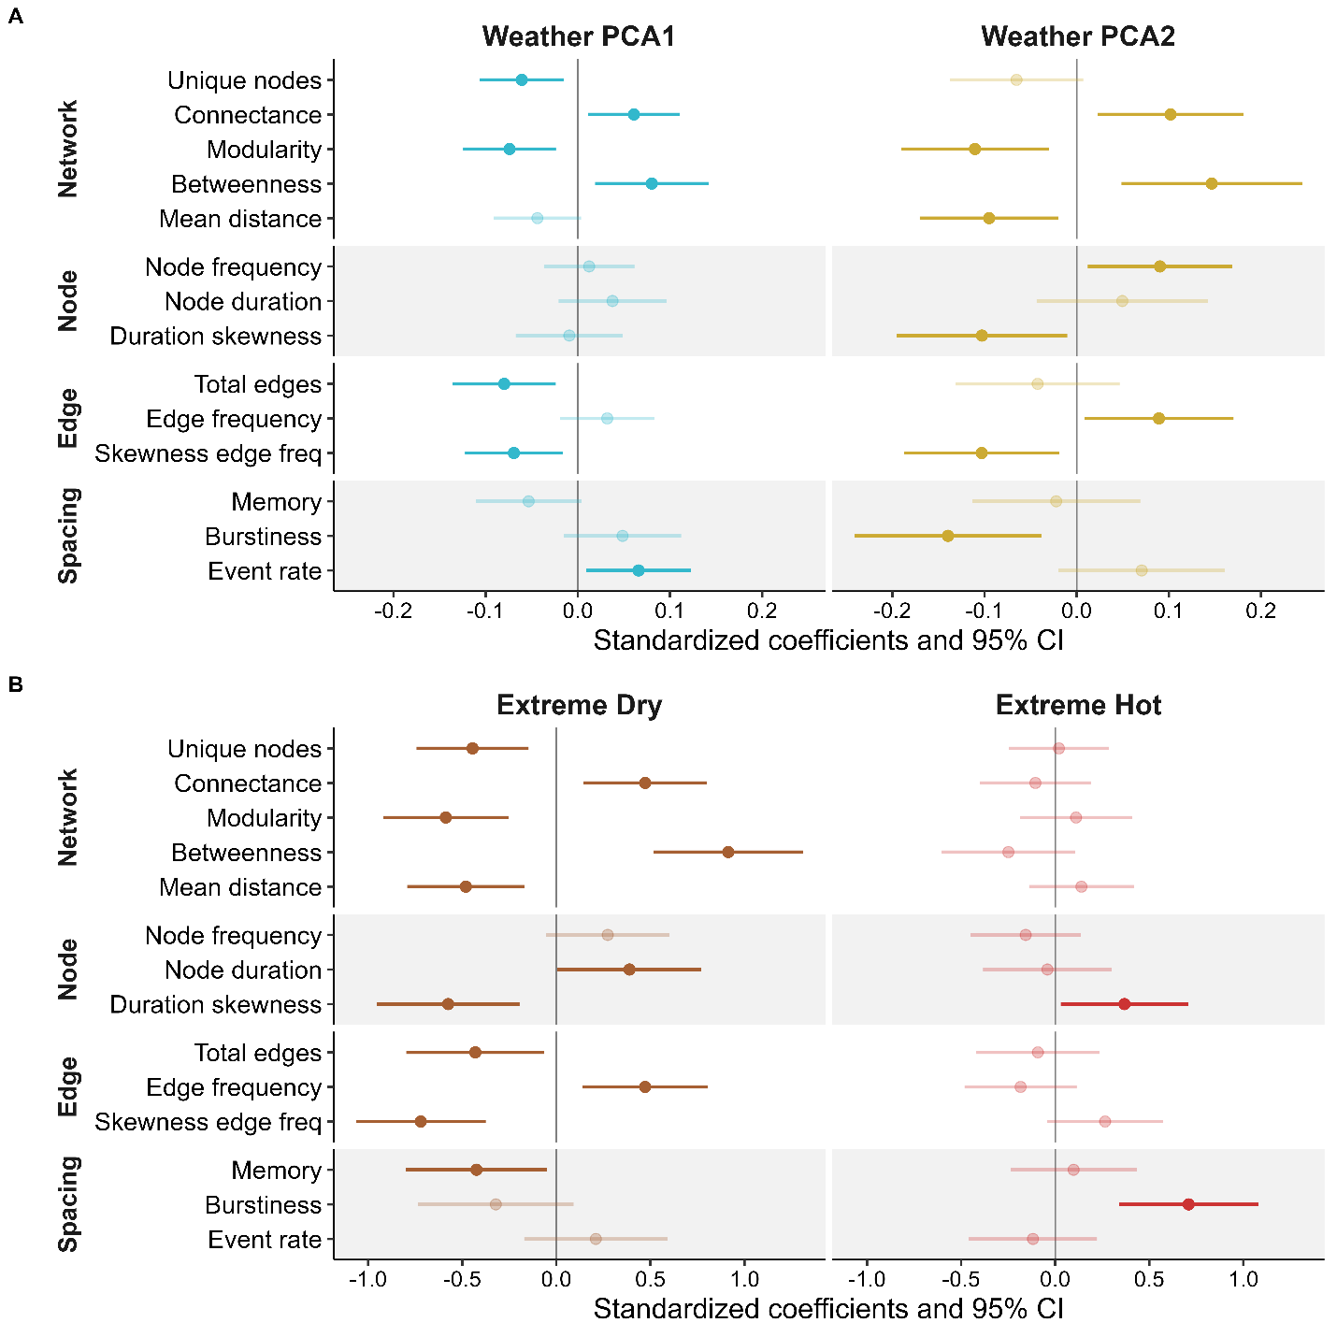Figure 4: Weather conditions and extreme climate shape the seasonal structure of community transitions. The individual network metrics (see Table 1 for full description) on the y-axis characterize the temporal organization of community changes across 24 years and 8 sites. (A) Shows how their inter-annual variation is associated with changes in annual climate conditions, summarized by two PC axis representing 9 weather variables (see supplement Fig. S1 for details on PC loadings). High values on PCA1 are associated with drier and hotter daytime conditions, while higher values on PCA2 reflect more steady (less temporally clustered pulses of) rainfall events throughout the year and warmer nights. (B) Shows how the structure of community transition networks changes in years with extreme dry (low cumulative rainfall and long dry periods) or hot conditions (high daily maximum temperatures and total number of hot days, see Fig. 5). The X-axis shows the standardized effect size. For ease of comparison, all metrics and climate variables were standardized prior to analysis.
Extreme climate events simplify the temporal architecture of communities
The multifaceted interplay among weather variables complicates isolating the role of individual drivers, but we can clarify these dependencies by focusing on extreme climatic events. Since both temperature and precipitation are the most important climatic drivers of amphibian breeding (25, 30), we focused on years with extremely high temperatures and drought conditions (see methods). We found the temporal architecture of communities changed significantly during years with extreme climatic events (Fig. 4B, Table S5). Unusually hot years triggered a shift toward more bursty (temporally clustered) transitions between community states and resulted in a more “extreme” long node durations (higher skew) but did not significantly alter other network metrics (Fig. 4B). In contrast, extreme drought restructured multiple aspects of the transition network, affecting 6 of 14 network metrics (Fig. 4B). Because drought years also encompassed four of the seven hottest years in the study, these periods represent naturally compounded climatic extremes. The inherent rarity of such climatic extremes makes it difficult to statistically disentangle both and might potentially miss more subtle effects, even in a 24-year data set. However, our analysis includes the five driest years of the past half-century and the five hottest years of the past century, ensuring that the observed shifts reflect the impact of true climatic extremes.

Under average climate conditions, communities had a ~25% higher diversity of community states. The drought-mediated reduction in network size was mostly driven by a loss of multi-species (three or more) states. However, this loss was independent of annual species diversity, which remained stable across extreme hot (P=0.235, χ² =1.41) and dry years (P=0.620, χ² =0.25). Instead, incorporating annual species richness as a covariate only strengthened the results (for all six metrics, Table S6), indicating that this network simplification was driven by changes in assembly rules rather than by taxonomic loss.
This drought-mediated reduction in network size was coupled with a significant increase in connectance, betweenness centrality, and frequency, while modularity and mean path length decreased (Fig. 4B, Table S5). These shifts represent a fundamental reorganization of the network architecture: while normal years favored more sequential transitions between states, forming a “circular” topology, drought years converged on a simpler “star” shaped topology (Fig. 5). In this more centralized configuration, single-species and no-species states formed “hubs”, overriding the diverse modular transition patterns typical during normal conditions. This structural simplification suggests a breakdown in temporal coordination among species, in which extreme climatic forcing appears to override biological assembly rules, creating a more bottlenecked architecture that may reduce community resilience to additional perturbations.
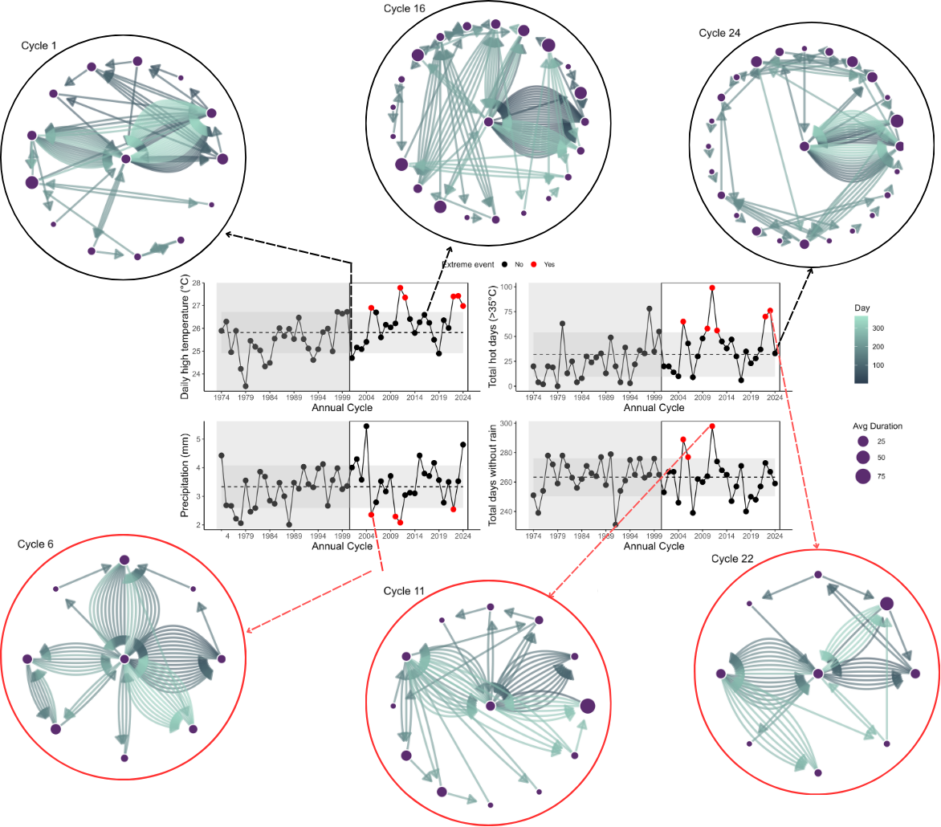Figure 5: The architecture of community transition networks differs between normal and extreme climate years. Nodes indicate unique combinations of co-occurring species (see Fig. 1), and their size indicates their average duration. Arrows indicate transitions between community states, with each color corresponding to a day. Top row shows examples for normal years, bottom row shows extreme climate years for the same pond. The center graphs show annual averages for temperature and rainfall metrics used to identify extreme climatic events (drought and heat), with the dashed line and gray shading indicating the 24-year average ±1SE, respectively.
These changes in the temporal structure of communities are consistent with the system’s biology. Amphibian breeding activity is strongly tied to precipitation (25), but because species have distinct seasonal reproductive windows (31), prolonged drought periods inevitably increase the temporal separation of species. This also weakens seasonal guild structure (as indicated by reduced modularity) and limits opportunities for co-occurrences and thus multi-species states (as reflected in lower node diversity). The notable exceptions are precipitation-insensitive species with prolonged breeding, like L. clamitans in our system, which emerge as central network hubs. Such differences in climate sensitivities are common across animal and plant taxa (8, 12), suggesting that these results should extend beyond amphibian breeding systems. Together, our findings highlight the role climate plays in shaping the temporal organization of communities and underscore the necessity of temporally explicit approaches to identify functional roles in systems driven by ephemeral resources.
Natural communities are complex, and any given metric and approach can only describe part of this complexity. Here, we focused on co-occurrence calling data, which are widely used to study environmental effects on community dynamics and interaction patterns (32-34). Extending this analysis to include abundance and direct interaction data could further enhance our understanding of the complex temporal structure of communities. Unfortunately, this data is still unavailable in most systems at fine temporal scales, and current analytical approaches are not yet designed to incorporate this information into temporal networks. However, advances in survey technology and computational methods are advancing quickly and hopefully will soon overcome this limitation (6). Furthermore, incorporating microclimate differences across sites could help explain some of the spatiotemporal differences across sites observed in our study.

Implications
Amphibians are among the most climate-sensitive (35) (36) and threatened taxa globally (24). Our results indicate that climatic extremes are not only threatening individual species but also the temporal architecture of entire communities. The co-occurrence of species determines what interactions and outcomes are possible (3, 6, 29) and the temporal patterns in adult breeding activity are correlated with the temporal community structure of the next generation (tadpole communities) (27). Thus, the observed shifts in the temporal architecture are expected to alter interactions at both the adult and larval stages of amphibians, with cascading effects for community dynamics and the crucial functional roles they play in both terrestrial and aquatic ecosystems.
The temporal architecture of communities is an emergent property of the phenological responses of all community members and their coordination. The small-world transition network architecture and the response to climate variation we discovered here are driven by species' phenological plasticity. Phenological plasticity is a common key adaptation to seasonal environments (37-43), suggesting that extreme climate events should alter the temporal structure of communities in most natural systems. However, climate sensitivities vary across taxa (8-12, 36, 41), and systematic differences in the temporal architecture of communities across systems and regions could modify the effect of extreme events. Given the highly dynamic and ephemeral nature of amphibian breeding activity, our results are likely to represent some of the most sensitive and dynamic communities along this natural spectrum. Thus, we expect that systems with slower species turnover and less plastic phenologies may exhibit different and potentially less sensitive temporal structures. As fine-resolution long-term phenology data become more available for other communities in the future, identifying how differences in temporal architecture shape communities' responses to climatic variation is a critical next step toward fully understanding the ecological and evolutionary factors that shape natural ecosystems and their sensitivity to environmental change.

References
1. B. Schwarz et al., Temporal scale-dependence of plant–pollinator networks. Oikos 129, 1289–1302 (2020).
2. P. J. CaraDonna et al., Seeing through the static: the temporal dimension of plant–animal mutualistic interactions. Ecology Letters 24, 149–161 (2021).
3. J. M. Olesen, J. Bascompte, H. Elberling, P. Jordano, Temporal dynamics in a pollination network. Ecology 89, 1573–1582 (2008).
4. P. J. CaraDonna et al., Interaction rewiring and the rapid turnover of plant–pollinator networks. Ecology letters 20, 385–394 (2017).
5. T. Petanidou, A. S. Kallimanis, J. Tzanopoulos, S. P. Sgardelis, J. D. Pantis, Long‐term observation of a pollination network: fluctuation in species and interactions, relative invariance of network structure and implications for estimates of specialization. Ecology letters 11, 564–575 (2008).
6. H. Yin, V. H. W. Rudolf, Time is of the essence: A general framework for uncovering temporal structures of communities. Ecology Letters 27, e14481 (2024).
7. E. M. Wolkovich, B. I. Cook, K. K. McLauchlan, T. J. Davies, Temporal ecology in the Anthropocene. Ecology Letters 17, 1365–1379 (2014).
8. S. J. Thackeray et al., Phenological sensitivity to climate across taxa and trophic levels. Nature 535, 241–245 (2016).
9. O. Ovaskainen et al., Community-level phenological response to climate change. Proceedings of the National Academy of Sciences 110, 13434–13439 (2013).
10. F. Duchenne et al., Phenological shifts alter the seasonal structure of pollinator assemblages in Europe. Nature Ecology & Evolution 4, 115–121 (2020).
11. A. M. Iler et al., Maintenance of temporal synchrony between syrphid flies and floral resources despite differential phenological responses to climate. Global Change Biology 19, 2348–2359 (2013).
12. R. M. Prather et al., Current and lagged climate affects phenology across diverse taxonomic groups. Proceedings of the Royal Society B-Biological Sciences 290, 20222181 (2023).
13. D. W. Inouye, Climate change and phenology. WIREs Climate Change 13, e764 (2022).
14. H. M. Kharouba et al., Global shifts in the phenological synchrony of species interactions over recent decades. Proceedings of the National Academy of Sciences 115, 5211–5216 (2018).
15. F. Duchenne, R. O. Wüest, C. H. Graham, Seasonal structure of interactions enhances multidimensional stability of mutualistic networks. Proceedings of the Royal Society B-Biological Sciences 289, 20220064 (2022).
16. F. Duchenne, C. Fontaine, E. Teulière, E. Thébault, Phenological traits foster persistence of mutualistic networks by promoting facilitation. Ecology Letters 24, 2088–2099 (2021).
17. F. Encinas‐Viso, T. A. Revilla, R. S. Etienne, Phenology drives mutualistic network structure and diversity. Ecology Letters 15, 198–208 (2012).
18. J. D. Tonkin, M. T. Bogan, N. Bonada, B. Rios-Touma, D. A. Lytle, Seasonality and predictability shape temporal species diversity. Ecology 98, 1201–1216 (2017).
19. S. S. Suzuki, Y. G. Baba, H. Toju, Dynamics of species-rich predator–prey networks and seasonal alternations of core species. Nature Ecology & Evolution 7, 1432–1443 (2023).
20. K. O. Winemiller, Spatial and temporal variation in tropical fish trophic networks. Ecological Monographs 60, 331–367 (1990).
21. P. J. CaraDonna, N. M. Waser, Temporal flexibility in the structure of plant–pollinator interaction networks. Oikos 129, 1369–1380 (2020).
22. S. Kortsch et al., Disentangling temporal food web dynamics facilitates understanding of ecosystem functioning. Journal of Animal Ecology 90, 1205–1216 (2021).
23. J. M. Cohen, M. J. Lajeunesse, J. R. Rohr, A global synthesis of animal phenological responses to climate change. Nature Climate Change 8, 224–228 (2018).
24. M. C. Urban, Climate change extinctions. Science 386, 1123–1128 (2024).
25. D. Saenz, L. A. Fitzgerald, K. A. Baum, R. N. Conner, Abiotic correlates of anuran calling phenology: The importance of rain, temperature, and season. Herpetological Monographs, 64–82 (2006).
26. J. B. Wilson, Guilds, functional types and ecological groups. Oikos, 507–522 (1999).
27. C. M. Carroll, D. Saenz, V. H. W. Rudolf, Tracking phenological distributions and interaction potential across life stages. Oikos 2023, e09773 (2023).
28. J. A. Dunne, R. J. Williams, N. D. Martinez, Food-web structure and network theory: The role of connectance and size. Proceedings of the National Academy of Sciences of the United States of America 99, 12917–12922 (2002).
29. J. Resasco, N. P. Chacoff, D. P. Vázquez, Plant–pollinator interactions between generalists persist over time and space. Ecology 102, e03359 (2021).
30. W. E. Duellman, L. Trueb, Biology of amphibians. (JHU press, 1994).
31. S. K. Carter, D. Saenz, V. H. Rudolf, Shifts in phenological distributions reshape interaction potential in natural communities. Ecology Letters 21, 1143–1151 (2018).
32. M. A. Freilich, E. Wieters, B. R. Broitman, P. A. Marquet, S. A. Navarrete, Species co-occurrence networks: Can they reveal trophic and non-trophic interactions in ecological communities? Ecology 99, 690–699 (2018).
33. L. A. Burkle, J. C. Marlin, T. M. Knight, Plant-pollinator interactions over 120 years: loss of species, co-occurrence, and function. Science 339, 1611–1615 (2013).
34. N. Galiana, J.-F. Arnoldi, F. Mestre, A. Rozenfeld, M. B. Araújo, Power laws in species’ biotic interaction networks can be inferred from co-occurrence data. Nature Ecology & Evolution, (2023).
35. D. Loughnan et al., Phenology varies with phylogeny but not by trophic level with climate change. Nature Ecology & Evolution 8, 1889–1896 (2024).
36. T. L. Root et al., Fingerprints of global warming on wild animals and plants. Nature 421, 57–60 (2003).
37. J. R. K. Forrest, J. D. Thomson, An examination of synchrony between insect emergence and flowering in Rocky Mountain meadows. Ecological Monographs 81, 469–491 (2011).
38. J. A. Dunne, J. Harte, K. J. Taylor, Subalpine meadow flowering phenology responses to climate change: Integrating experimental and gradient methods. Ecological Monographs 73, 69–86 (2003).
39. A. M. Iler, D. W. Inouye, N. M. Schmidt, T. T. Høye, Detrending phenological time series improves climate–phenology analyses and reveals evidence of plasticity. Ecology 98, 647–655 (2017).
40. K. Donohue, Niche construction through phenological plasticity: life history dynamics and ecological consequences. New Phytologist 166, 83–92 (2005).
41. C. Parmesan, G. Yohe, A globally coherent fingerprint of climate change impacts across natural systems. Nature 421, 37–42 (2003).
42. V. Radchuk et al., Adaptive responses of animals to climate change are most likely insufficient. Nature communications. 10, 3109 (2019).
43. O. Vedder, S. Bouwhuis, B. C. Sheldon, Quantitative Assessment of the Importance of Phenotypic Plasticity in Adaptation to Climate Change in Wild Bird Populations. PLOS Biology 11, e1001605 (2013).

Acknowledgments: We thank Cory Adams, James Childress, Erin Childress and Alexandria Bryant for contributing in the field and lab. Additional thanks to Amy Dunham and Tom EX Miller for comments on the manuscript. This paper was written and prepared in part by a U.S. Government employee on official time and therefore is in the public domain and not subject to copyright. This research was supported in part by the USDA Forest Service. The findings and conclusions in this publication are those of the author(s) and should not be construed to represent an official USDA, Forest Service, or U.S. Government determination or policy.
Funding: VHWR was supported by NSF DEB-2445952.
Author Contributions: Conceptualization, formal data analysis, writing - original draft: VHWR
Data Collection and curation: DS
Writing-editing: VHWR & DS
Competing interests: Authors declare that they have no competing interests.
Data, code, and materials availability: All data, code, and materials are freely available at:

Supplementary Materials
Materials and Methods
Supplementary Text
Figs. S1 to S8
Tables S1 to S8

